**Project Overview**: The main purpose of the project is to complete the election audit of the recent local congressional election in Colorado. To provide the result of the election, we were directed to use the PyPoll_Challenge .py and the election_result.csv to calculate the total votes cast in the congressional election. We are also asking to break down the number of votes, the percentage of each county, and to calculate the county with the largest number of votes. Finally, to provide the percentages of the total votes each candidate received, the winner, their votes, and the percentages of the total votes. We were provided the PyPoll_Challenge .py and the electione_result.csv via python and Visual Studio Code software.

**Election- Audit Summary**: the final election result shows that 369,711 votes were cast in general during the congressional election. Jefferson received 38,855 votes which are 10.5 percent of the total votes. Denver received 306,055 votes which are 82.8 percent of the total votes. Arapahoe received 24,801 votes which are 6,7 percent of the total votes. Denver was declared the county with the largest number of votes. The candidates' results are Charles caper Stockham received 85,213 votes which is 23 percent of the total votes. Diana Degette received 272,892 votes which are 73.8 percent of the total votes. Raymon Anthony received 11,606 votes which are 3.1 percent of the total votes. Diana Degette received 272,892 votes which is 73.8 percent of the total votes was declared the winner of the congressional election.

[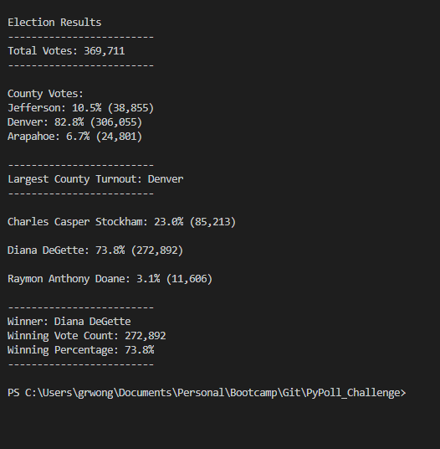](https://github.com/grwon/PyPoll_Challenge/blob/master/analysis/OutputToCommandLineResults.png)

**Script**: The script provides the complete picture of the congressional election. It gives the election result of each county and the candidates. It also provides the winner in each county and winners in the three precincts. With some modifications, such as the changes of candidates' names and candidates' identities, the script can be modified for other elections. While candidate varies from years to years, the county remains the same over a long period unless there is re-distribution of the county that normally happened every decade.